**LAB 9: DISK SCHEDULING**

Suppose the head of a moving- head disk with 200 tracks, numbered 0 to 199 is currently serving request at tracks 143 and has finished a request at track 125. The queue it requests is kept in the FIFO order 86, 147, 91, 177, 94, 150, 102, 175, 130. Write a program to calculate the total head movement using following algorithms.

• FCFS

• SSTF

• SCAN

• C-SCAN

• LOOK

• C-LOOK

CODES:

**For FCFS**

#include <stdio.h>

#include <stdlib.h>

int main()

{

int RQ[100],i,n,TotalHeadMoment=0,initial;

printf("Enter the number of Requests: ");

scanf("%d",&n);

printf("Enter the Requests sequence: ");

for(i=0;i<n;i++)

scanf("%d",&RQ[i]);

printf("Enter initial head position: ");

scanf("%d",&initial);

for(i=0;i<n;i++)

{

TotalHeadMoment=TotalHeadMoment+abs(RQ[i]-initial);

initial=RQ[i];

}

printf("Total head moment is %d\n",TotalHeadMoment);

return 0;

}

**Output:**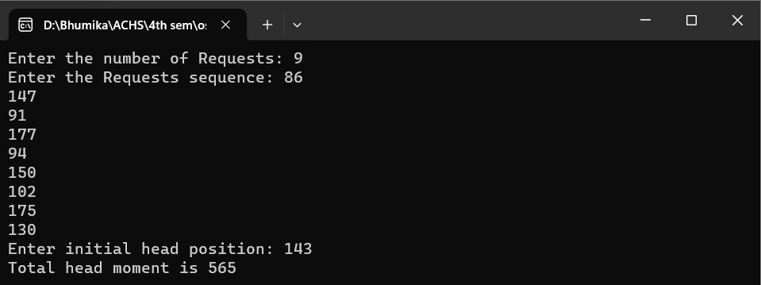

**For SSTF**

 #include <stdio.h>

 #include <stdlib.h>

 int main()

 {

    int RQ[100],i,n,TotalHeadMoment=0,initial,count=0;

 printf("Enter the number of Requests: ");

 scanf("%d",&n);

 printf("Enter the Requests sequence: ");

 for(i=0;i<n;i++)

  scanf("%d",&RQ[i]);

  printf("Enter initial head position: ");

  scanf("%d",&initial);

  // logic for sstf disk scheduling

  /* loop will execute until all process is completed*/

  while(count!=n)

  {

     int min=1000,d,index;

  for(i=0;i<n;i++)

  {

     d=abs(RQ[i]-initial);

  if(min>d)

  {

     min=d;

  index=i;

  }

  }

  TotalHeadMoment=TotalHeadMoment+min;

  initial=RQ[index];

  // 1000 is for max

  // you can use any number

  RQ[index]=1000;

  count++;

  }

  printf("Total head movement is %d\n",TotalHeadMoment);

  return 0;

}

**Output:**

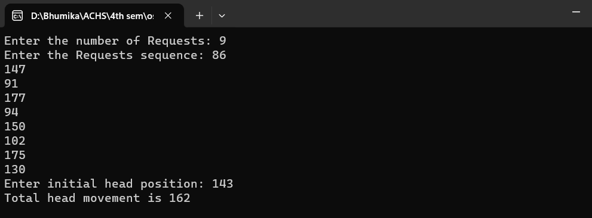

**For SCAN:**

 #include <stdio.h>

  #include <stdlib.h>

  int main() {

     int RQ[100],i,j,n,TotalHeadMoment=0,initial,size,move;

  printf("Enter the number of Requests: ");

  scanf("%d",&n);

  printf("Enter the Requests sequence: ");

  for(i=0;i<n;i++)

  scanf("%d",&RQ[i]);

printf("Enter initial head position: ");

scanf("%d",&initial);

printf("Enter total disk size: ");

scanf("%d",&size);

printf("Enter the head movement direction for high 1 and for low 0: ");

scanf("%d",&move);

// logic for Scan disk scheduling

/*logic for sort the request array */

for(i=0;i<n;i++) {

for(j=0;j<n-i-1;j++) {

if(RQ[j]>RQ[j+1]) {

int temp;

temp=RQ[j];

RQ[j]=RQ[j+1];

RQ[j+1]=temp;

}

}

}

int index;

for(i=0;i<n;i++) {

if(initial<RQ[i]) {

index=i;

break;

}

}

// if movement is towards high value

if(move==1) {

for(i=index;i<n;i++) {

TotalHeadMoment=TotalHeadMoment+abs(RQ[i]-initial);

initial=RQ[i];

}

// last movement for max size

TotalHeadMoment=TotalHeadMoment+abs(size-RQ[i-1]-1);

initial = size-1;

for(i=index-1;i>=0;i--) {

TotalHeadMoment=TotalHeadMoment+abs(RQ[i]-initial);

initial=RQ[i];

}

}

// if movement is towards low value

else {

for(i=index-1;i>=0;i--) {

TotalHeadMoment=TotalHeadMoment+abs(RQ[i]-initial);

initial=RQ[i];

}

// last movement for min size

TotalHeadMoment=TotalHeadMoment+abs(RQ[i+1]-0);

initial =0;

for(i=index;i<n;i++) {

TotalHeadMoment=TotalHeadMoment+abs(RQ[i]-initial);

initial=RQ[i];

}

}

printf("Total head movement is %d\n",TotalHeadMoment);

return 0;

}

**Output:**

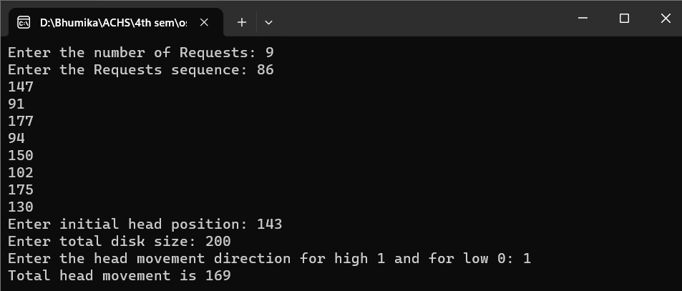

**For CSCAN**

 #include <stdio.h>

#include <stdlib.h>

int main() {

int RQ[100],i,j,n,TotalHeadMoment=0,initial,size,move;

printf("Enter the number of Requests: ");

scanf("%d",&n);

printf("Enter the Requests sequence: ");

for(i=0;i<n;i++)

scanf("%d",&RQ[i]);

 printf("Enter initial head position: ");

 scanf("%d",&initial);

 printf("Enter total disk size: ");

 scanf("%d",&size);

 printf("Enter the head movement direction for high 1 and for low 0: ");

 scanf("%d",&move);

 // logic for C-Scan disk scheduling

 /*logic for sort the request array */

 for(i=0;i<n;i++) {

 for( j=0;j<n-i-1;j++) {

 if(RQ[j]>RQ[j+1]) {

 int temp;

 temp=RQ[j];

 RQ[j]=RQ[j+1];

 RQ[j+1]=temp;

 }

 }

 }

 int index;

 for(i=0;i<n;i++) {

 if(initial<RQ[i]) {

 index=i;

 break;

 }

 }

 // if movement is towards high value

 if(move==1) {

 for(i=index;i<n;i++) {

 TotalHeadMoment=TotalHeadMoment+abs(RQ[i]-initial);

 initial=RQ[i];

 }

 // last movement for max size

 TotalHeadMoment=TotalHeadMoment+abs(size-RQ[i-1]-1);

 /*movement max to min disk */

 TotalHeadMoment=TotalHeadMoment+abs(size-1-0);

 initial=0;

 for( i=0;i<index;i++) {

 TotalHeadMoment=TotalHeadMoment+abs(RQ[i]-initial);

 initial=RQ[i];

 }

 }

 // if movement is towards low value

 else {

 for(i=index-1;i>=0;i--) {

 TotalHeadMoment=TotalHeadMoment+abs(RQ[i]-initial);

 initial=RQ[i];

 }

 // last movement for min size

 TotalHeadMoment=TotalHeadMoment+abs(RQ[i+1]-0);

 /*movement min to max disk */

 TotalHeadMoment=TotalHeadMoment+abs(size-1-0);

 initial =size-1;

 for(i=n-1;i>=index;i--) {

 TotalHeadMoment=TotalHeadMoment+abs(RQ[i]-initial);

 initial=RQ[i];

 }

 }

 printf("Total head movement is %d\n",TotalHeadMoment);

 return 0;

 }

**Output:**

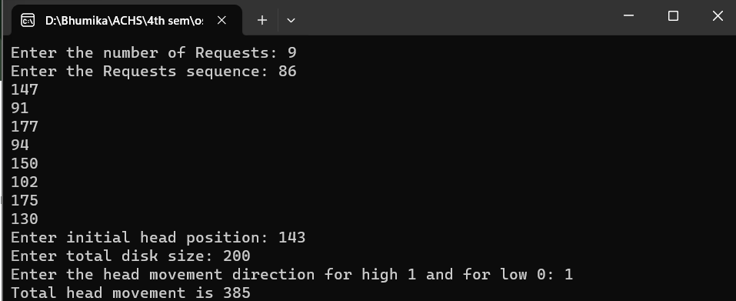

**For Look:**

#include <stdio.h>

#include <stdlib.h>

int main() {

    int RQ[100],i,j,n,TotalHeadMoment=0,initial,size,move;

printf("Enter the number of Requests: ");

scanf("%d",&n);

printf("Enter the Requests sequence: ");

for(i=0;i<n;i++)

scanf("%d",&RQ[i]);

 printf("Enter initial head position: ");

 scanf("%d",&initial);

 printf("Enter total disk size: ");

 scanf("%d",&size);

 printf("Enter the head movement direction for high 1 and for low 0: ");

 scanf("%d",&move);

 /*logic for sort the request array */

 for(i=0;i<n;i++) {

     for(j=0;j<n-i-1;j++) {

     if(RQ[j]>RQ[j+1])

 {

     int temp;

 temp=RQ[j];

 RQ[j]=RQ[j+1];

 RQ[j+1]=temp;

 } } }

 int index;

 for(i=0;i<n;i++) {

     if(initial<RQ[i]) {

     index=i;

 break;

 }

 }

 if(move==1) {

     for(i=index;i<n;i++) {

     TotalHeadMoment=TotalHeadMoment+abs(RQ[i]-initial);

 initial=RQ[i];

 }

 for(i=index-1;i>=0;i--) {

     TotalHeadMoment=TotalHeadMoment+abs(RQ[i]-initial);

 initial=RQ[i];

 }

 }

 else {

     for(i=index-1;i>=0;i--) {

     TotalHeadMoment=TotalHeadMoment+abs(RQ[i]-initial);

 initial=RQ[i];

 }

for(i=index;i<n;i++) {

TotalHeadMoment=TotalHeadMoment+abs(RQ[i]-initial);

initial=RQ[i];

}

}

printf("Total head movement is %d\n",TotalHeadMoment);

return 0;

}

**Output:**

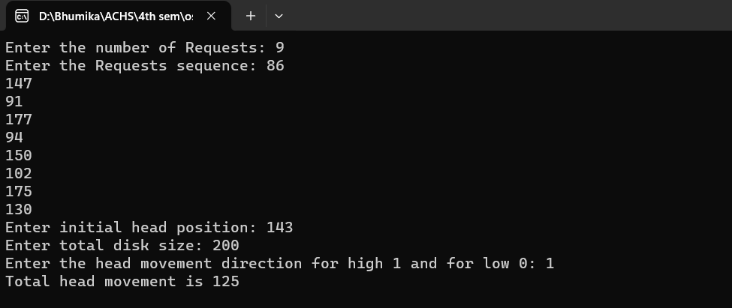

**For C Look**

 #include <stdio.h>

 #include <stdlib.h>

 int main() {

    int RQ[100],i,j,n,TotalHeadMoment=0,initial,size,move;

 printf("Enter the number of Requests: ");

 scanf("%d",&n);

 printf("Enter the Requests sequence: ");

 for(i=0;i<n;i++)

 scanf("%d",&RQ[i]);

  printf("Enter initial head position: ");

  scanf("%d",&initial);

  printf("Enter total disk size: ");

  scanf("%d",&size);

  printf("Enter the head movement direction for high 1 and for low 0: ");

  scanf("%d",&move);

  for(i=0;i<n;i++) {

     for( j=0;j<n-i-1;j++) {

     if(RQ[j]>RQ[j+1]){

     int temp;

  temp=RQ[j];

  RQ[j]=RQ[j+1];

  RQ[j+1]=temp;

  }

  }

  }

  int index;

  for(i=0;i<n;i++) {

     if(initial<RQ[i]) {

     index=i;

  break;

  }

  }

  if(move==1) {

     for(i=index;i<n;i++) {

     TotalHeadMoment=TotalHeadMoment+abs(RQ[i]-initial);

  initial=RQ[i];

  }

  for( i=0;i<index;i++) {

     TotalHeadMoment=TotalHeadMoment+abs(RQ[i]-initial);

  initial=RQ[i];

  } }

else {

     for(i=index-1;i>=0;i--) {

     TotalHeadMoment=TotalHeadMoment+abs(RQ[i]-initial);

  initial=RQ[i];

  }

  for(i=n-1;i>=index;i--) {

  TotalHeadMoment=TotalHeadMoment+abs(RQ[i]-initial);

  initial=RQ[i];

  }

  }

  printf("Total head movement is %d\n",TotalHeadMoment);

  return 0;

  }

**Output:**

